 

INSTITUTE FOR ADVANCED

COMPUTING AND SOFTWARE

DEVELOPMENT AKURDI, PUNE

Documentation On

**“Restaurant Table Reserving System”**

E-DAC SEPT 2021

*Submitted By:*

**Group No: 33**

**Miss. Yogyashri Bhaurao Chine 1039**

**Miss. Sayali Rohit Bhosale 1184**

**Mr. Prashant Karhale Mr. Kashinath Patil**

**Centre Coordinator Project Guide**

ii

# Table of Contents

1. **Introduction ...................................................................................................................01** 
   1. Document Purpose ....................................................................................................01
   2. Problem Statement ....................................................................................................02
   3. Product Scope ............................................................................................................02
   4. Aim and Objectives ...................................................................................................02
2. **Overall Description ............................................................. ......................................... 03** 
   1. Product Perspective ...................................................................................................03
   2. Benefits …………………. .......................................................................................04
   3. User and Characteristics ............................................................................................04
   4. Operating Environment .............................................................................................05
   5. Design and Implementation Constraints ................................................................... 5
3. **Requirements Specification...........................................................................................06** 
   1. External Interface Requirements ...............................................................................06
4. **System Diagram .............................................................................................................07**
   1. Sequence Diagram ....................................................................................................07
   2. Data Flow Diagram ................................................................................................. 08
   3. Class Diagram ......................................................................................................... 09
   4. Use Case Diagram ................................................................................................... 10
   5. ER Diagram ............................................................................................................. 11
5. **Table Structure ............................................................................................................. 13**
   1. Category ................................................................................................................... 13
   2. User ......................................................................................................................... 13
   3. Menu ....................................................................................................................... 13
   4. Reservation ..............................................................................................................14
   5. Reserved Table ........................................................................................................14
6. **Snapshots ...................................................................................................................... 15**
7. **Conclusion .................................................................................................................... 31** 
   1. Future Scope ........................................................................................................... 31
8. **References .................................................................................................................... 32**

iii

# List of Figures

Figure 1 Overall System Sequence Diadram................................................................... 09

Figure 2 Level 0 Data Flow Diagram............................................................................. 10

Figure 3 Class Diagram…………………….................................................................. 10

Figure 4 User/Customer Use Case Diagram... ................................................................ 11

Figure 5 ER Diagram for User.…….. ............................................................................ 11

Figure 5 ER Diagram for Admin…................................................................................ 11

Figure 5 ER Diagram for User.…….. ............................................................................ 11

iii

# 1.Introduction

The following section provides an overview of the derived Software

Requirements Specification (SRS) for the subject Restaurant Table Reservation

System (RTRS). To begin with, the purpose of the document is presented and

its intended audience outlined. Subsequently, the scope of the project specified

by the document is given with a particular focus on what the resultant software

will do and the relevant benefits associated with it. The nomenclature used thro

-ughout the SRS is also offered. To conclude, a complete document overview is

provided to facilitate increased reader comprehension and navigation.

Restaurant Table Reservation System is an web application (RTRS)

that applies in a restaurant table reservations benefit. RTRS involved the use of

five modules which are the reservation, view food Menu, View list of Categories,

Update Menu price and get in touch with us. Manual table reservation system are

ending up progressively in well-known restaurants as now a days people are get-

-ting into digital era of reservation of restaurants, and supplier are considering

while to choose a digital system of booking. Usually the restaurant tables‟ reserve

-ation system ought to give instruments to plan and run your restaurant appointme

-nts adequately in speedy and efficient ways. An effective table administration

implies that a restaurant can expand the potential utilization of their lounge area

and thusly should build benefits and for suppliers. A table reservation system for

any restaurant should have full perceivability and control of their seating plans

with a full graphical view, that can accessed by the customers at specific date and

time by sitting at anyplace through use of web application. The administrator can

be kept up the details of categories of food, reserved table and foods menu.

* 1. **Document Purpose**

The purpose of this SRS is to outline both the functional and non-functional requirements of the subject RTRS. In addition to said requirements, the document also provides a detailed profile of the external interfaces, performance considerations and design constraints imposed on the subsequent implementation. It is the intention that the presented set of requirements possesses the following qualities; correctness, unambiguousness, completeness, consistency, verifiability, modifiability and traceability. Consequently, the document should act as a foundation for efficient and well-managed project completion and further serve as an accurate reference in the future. The primary audience of this SRS document will be the development team employed to implement the specified RTRS.

The focus of the project is to computerize traveling company to manage data, so that all the transactions become fast and there should not be any error in transaction like calculation mistake, bill generation and other things. It replaces all the paper work. It keeps records of all bills also, giving to ensure 100% successful implementation of the computerized tour reservation.

This system has two modules for customer. First module helps the customer to enquire the availability of tables in a particular restaurant at particular date. Second module helps him to reserve a table and view ordered food.

* First module retrieves data from tables required for enquire.
* Second module inserts values into the tables on reservation.

As the database is hosted using MySQL onto internet, the application

can access data from any part of the world, by many number of people

concurrently.

* 1. **Problem Statement**

In the present situation a customer has to approach various restaurants to find details of available tables and Menu at particular restaurant. This often requires a lot of time and effort. A customer may not get the desired information from these restaurants and often the customer may be misguided. It is tedious for a customer to book a table properly

* 1. **Product Scope**

The scope of this project is to build an application for reserving table for restaur

ant. Through restaurant table reservation system online, users can be allowed to take

reservation quickly and easily. These reservations are completely under user’s control.

The user can choose and update their reservation as per their preference of date

and time. The manager doesn’t have to maintain a guest book anymore. The can see

who is coming and at what time. In that they are aware about which tables have been

booked and ordered food list. This method also makes it easy to change the status of

reservation once your guest walks in. Time management becomes simple. You can

also inform your restaurant staff about who has arrived as you have the information

about the customer from the database and how to take care of them. It also makes it

easy to let them know in case of cancelled reservations .

**1.4 Aims and Objectives**

The key objective of current project was to allow the management administer-

-tions and employees of a restaurant to grip the customers to view manu list of

Restaurant and to find free tables according to their required number of seats. RTRS

web application will enable the user to access and manage the arrangements of table,

view menu list view list of categories, view price of given food .

The general objective of RTRS was to build up a reservation system

for table reservation to assist workers with solving basic issues with their manual

reservation system for example utilization of time cash and vulnerability.

Specific objective

In particular the proposed system aims:

1) Easy in a hurry calling.

2) User-friendly.

3) To lessen the measure of time to and exertion utilization by the client to save.

4) Great for a minute ago reservations.

5) To enhance the correspondence between the customer and the administrations

and limit the season of requesting.

6) This website will be produced essentially to provide a proof for appropriate

client versatile cooperation.

**2.Overall Description**

**2.1 Product Perspective:**

1. **EXISTING SYSTEM**

In manual system, everything depends upon paper and there is no automated

system for keeping the records in restaurants. The menus which are accessible on

the restaurant is paper based. The request which has taken by the server is on paper

based and the bill created finally is also on paper based. We realized that this paper

based system is easily vulnerable to get harmed because of several reasons and it

leads to different problem i.e. waiters couldn‟t have arranged records of clients.

Moreover it prompts wastage of time and paper. On the other hand sometimes if

there is a need of little changes in the menu then supervisor need to print the entire

menu cards and it prompts papers and money wastage. Since it isn't conceivable to

print the entire menu over and over because of little changes. On the off chances

sometime supervisor need to review the records before the request. For this a hand

-ler needs to sit tight for taking order and recording request and follow up already

reserved hall made the old system of booking tedious. What's more for each little

request we need to call the waiter for a number of times and it prompts some misco

-nception from waiter side. So we need to roll out some improvements in the curre

-nt system to wipe out the above issues.

1. **PROPOSED SYSTEM**

In proposed ordering system we provide facility customers to reserve tables

for dining, and can also get details of Menu list and price of food. At the same time

this online reservation system will provide the restaurant owner to manage their

services including View food menu. Currently proposed system will be fast and

easy to use and involves the application of five modules which are the reservation

of table, view Categories of food, view menu, update price of menu and contact us.

This system will managed by two main web applications, first one would be

available for general customers for viewing and booking of table and view menu

card. Second would be used by the admin to update the manage the services with

in the restaurant premises.

**2.2 Benefits of RTRS**

The Benefits of proposed system are followings

* Provide client record and secret key to guarantee the security of put away documents.
* Rights are reserved at customer‟s fingertips.
* During festive seasons, tables get booked shortly, in such cases clients can make

advance booking for utilization of ordering framework.

* It saves client's time looking out for restaurants.
* It saves business assets and costs.
* It discourages the involvement of third party or a middle man by providing a direct

interface of customers to their service providers.

* It avoids to customers to pay heavy commission.

**2.3 Users and Characteristics:**

* Admin:

|  |  |
| --- | --- |
|  | * Admin can login to the system. |
|  | * View the list of all Category. |
|  | * View the list of all the menus |
|  | * View the list of all reservation |
|  | * View the list of all Users. |
| ➢ User: | * Add new Category * Add new menu |
|  | * User can login to the system. | |
|  | * View list of menus | |
|  | * View List of Categories. | |
|  | * Search Not Reserved Table in Restaurant. | |
|  | * Book Table in Restaurant as per time. | |
|  |  | |

**2.4 Operating Environment:**

* Server Side:

**Processor**: Intel core i5-6500 processor

**HDD**: Minimum 500GB Disk Space

**RAM**: Minimum 8GB

**OS**: Windows 7 or above

**Database**: MySQL6.3

**IDE**: STS3.9

* Client Side (minimum requirement):

**Processor:** Intel Dual Core

**HDD:** Minimum 80GB Disk Space

**RAM:** Minimum 4GB

**OS:** Windows 7 or above

**2.5 Design and Implementation Constraints:**

* + - The application will use React and Bootstrap as main web technologies.
    - HTTP and FTP protocols are used as communication protocols. FTP is used to upload the web application in live domain and the client can access it via HTTP protocol.
    - Several types of validations make this web application a secured one and SQL Injections can also be prevented.
    - Since RTRS is a web-based application, internet connection must be established.
    - The RTRS will be used on PCs and will function via internet or intranet in any web browser.

# 3.Requirement Specification

**3.1 External Interface Requirements:**

* User Interfaces:
  + All the users will see the same page when they enter in this website. This page asks the users a username and a password.
  + After being authenticated by correct username and password, user will be redirect to their corresponding profile where they can do various activities.
  + The user interface will be simple and consistence, using terminology commonly understood by intended users of the system. The system will have simple interface, consistence with standard interface, to eliminate need for user training of infrequent users.

O Hardware Interface:

* + No extra hardware interfaces are needed.
  + The system will use the standard hardware and data communication resources.
  + This includes, but not limited to, general network connection at the server/hosting site, network server and network management tools.
* Application Interfaces:

**OS:** Windows 7 and above

**Web Browser:**

The system is a web-based application; clients need a modern web browser such as Mozilla Firebox, Internet Explorer, Opera, and Chrome. The computer must have an Internet connection in order to be able to access the system.

* Communications Interfaces:
  + This system uses communication resources which includes but not limited to, HTTP protocol for communication with the web browser and web server and TCP/IP network protocol with HTTP protocol.
  + This application will communicate with the database that holds all the table booking information. Users can contact with server side through HTTP protocol by means of a function that is called HTTP Service. This function allows the application to use the data retrieved by server to fulfil the request fired by the user.

# 4.System Design

**4.1 Sequence Diagram :**

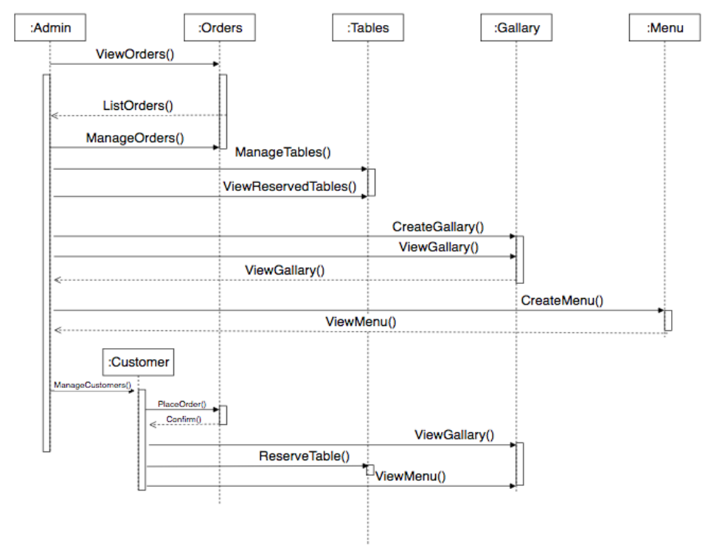

**Figure 1: Sequence diagram for overall system**

**4.2 Data Flow Diagram :**

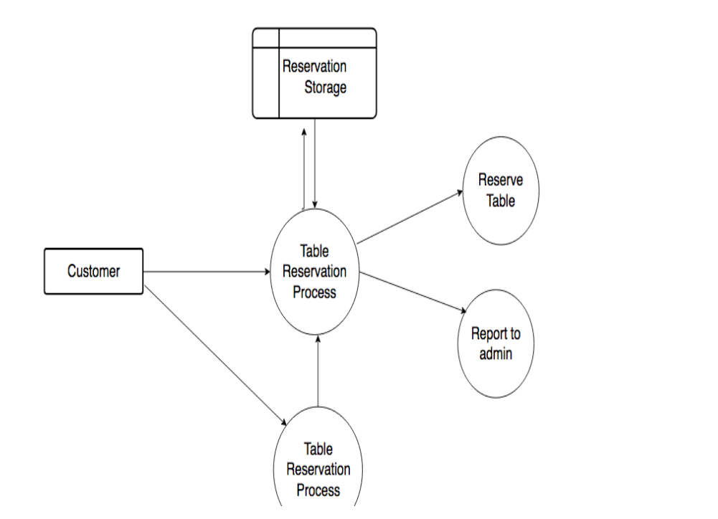

**Figure 2: Data Flow Diagram – Level 0**

**4.3 Class Diagram :**

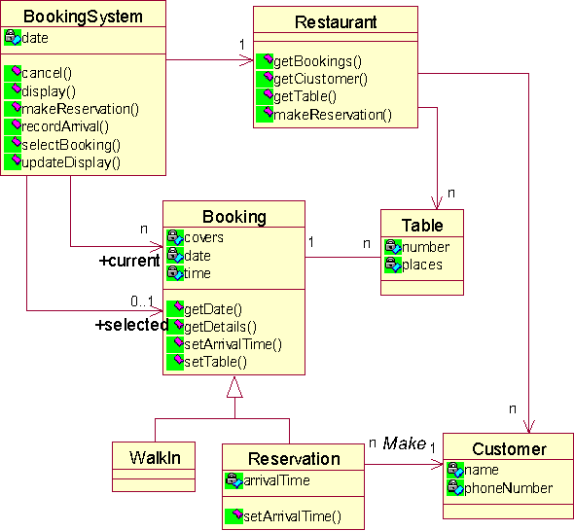

**Figure 3: Class Diagram**

**4.4 Use Case Diagram :**

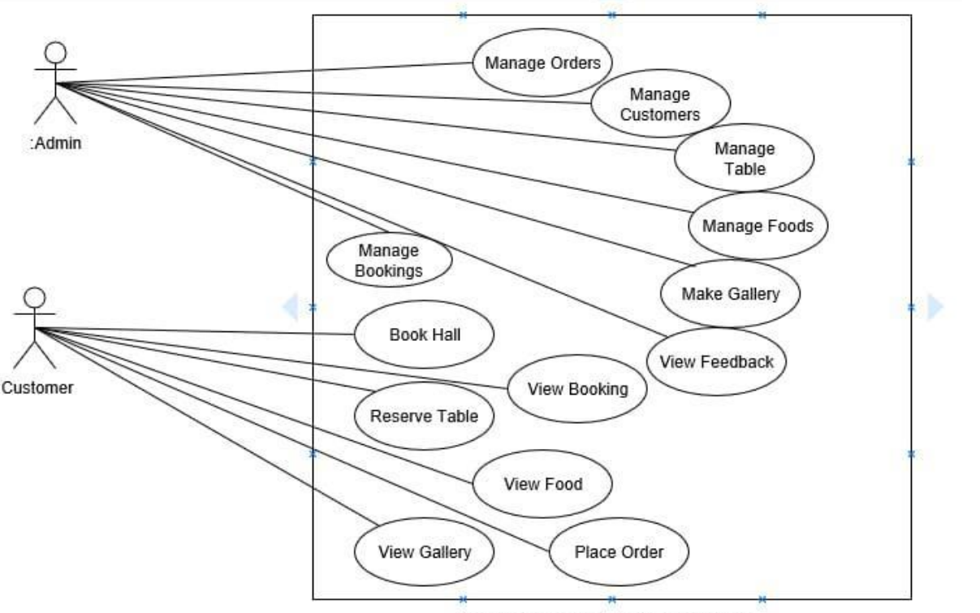

**Figure 4: Use Case Diagram**

## 4.5 ER Diagram :

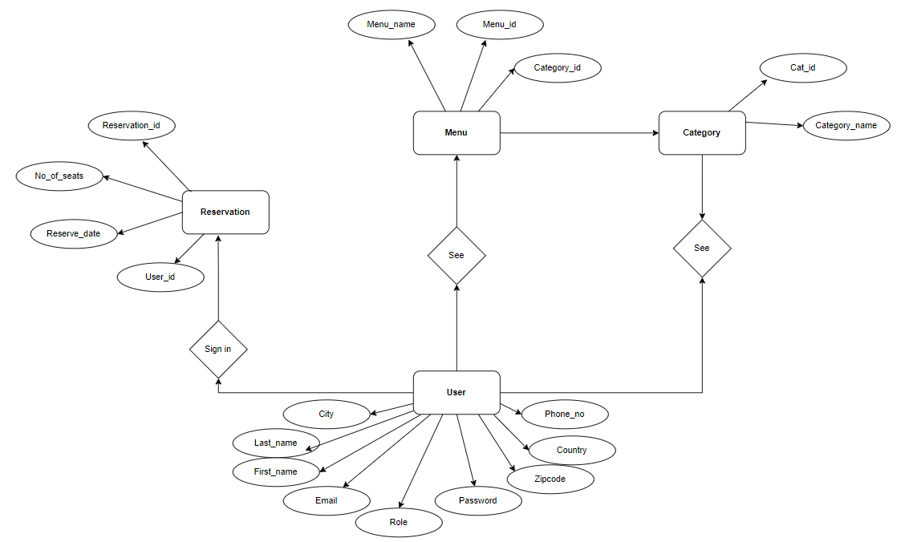

**Figure 10.1: ER Diagram for User**

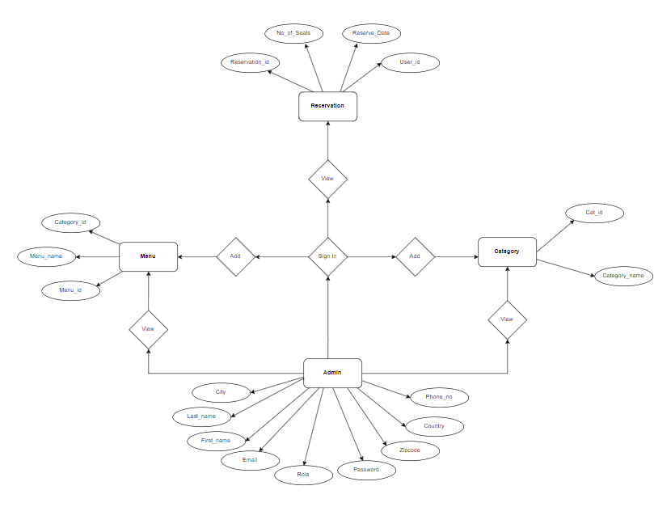**Figure 10.2: ER Diagram for Admin**

**5.Table Structure**

**5.1 User Table:**

|  |  |  |  |  |  |
| --- | --- | --- | --- | --- | --- |
| Field | Type | Null | Key | Default | Extra |
| User_id | Int | NO | PRI | NULL | Auto_increment |
| City | Varchar(30) | YES |  | NULL |  |
| Country | Varchar(30) | YES |  | NULL |  |
| Email | Varchar(20) | NO | UNI | NULL |  |
| First_name | Varchar(30) | YES |  | NULL |  |
| Last_name | Varchar(30) | YES |  | NULL |  |
| Password | Varchar(30) | NO |  | NULL |  |
| Phone no | Varchar(10) | YES | UNI | NULL |  |
| Role | Varchar(20) | YES |  | NULL |  |
| Zip_code | Varchar(30) | YES |  | NULL |  |

**5.2 Category Table:**

|  |  |  |  |  |  |
| --- | --- | --- | --- | --- | --- |
| Field | Type | Null | Key | Default | Extra |
| Cate_id | Int | NO | PRI | NULL | Auto_increment |
| Category_name | Varchar(30) | YES | UNI | NULL |  |

**5.3 Menu Table:**

|  |  |  |  |  |  |
| --- | --- | --- | --- | --- | --- |
| Field | Type | Null | Key | Default | Extra |
| Menu_id | Int | NO | PRI | NULL | Auto_increment |
| Menu_name | Varchar(30) | YES | UNI | NULL |  |
| Price | Double | NO |  | NULL |  |
| Category_id | Int | YES | MUL | NULL |  |

**5.5 Reservation Table:**

|  |  |  |  |  |  |
| --- | --- | --- | --- | --- | --- |
| Field | Type | Null | Key | Default | Extra |
| Reservation_id | Int | NO | PRI | NULL | Auto_increment |
| Booked | Bit | NO |  | NULL |  |
| Number_ofseats | Int | NO |  | NULL |  |
| Reserve_date | Datetime | YES |  | NULL |  |
| User_user_id | Int | YES | MUL | NULL |  |

**5.6 Reserved Table:**

|  |  |  |  |  |  |
| --- | --- | --- | --- | --- | --- |
| Field | Type | Null | Key | Default | Extra |
| Table_id | Int | NO | PRI | NULL | Auto_increment |
| Number_of_seats | Int | NO |  | NULL |  |

# 

# 6 SnapShots

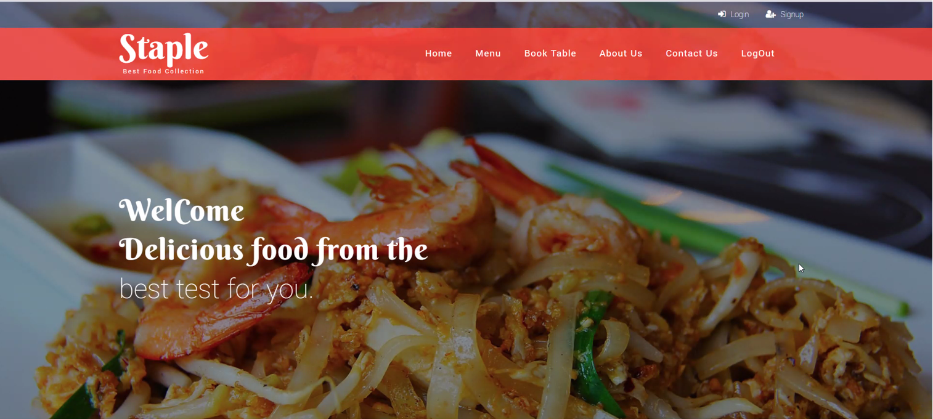

**Figure 1: Home Page [Before Login]**

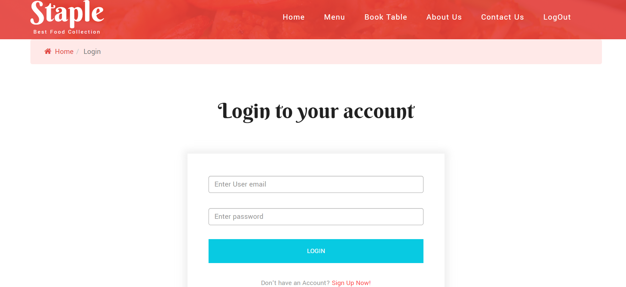

**Figure 2: Login Page [Empty]**

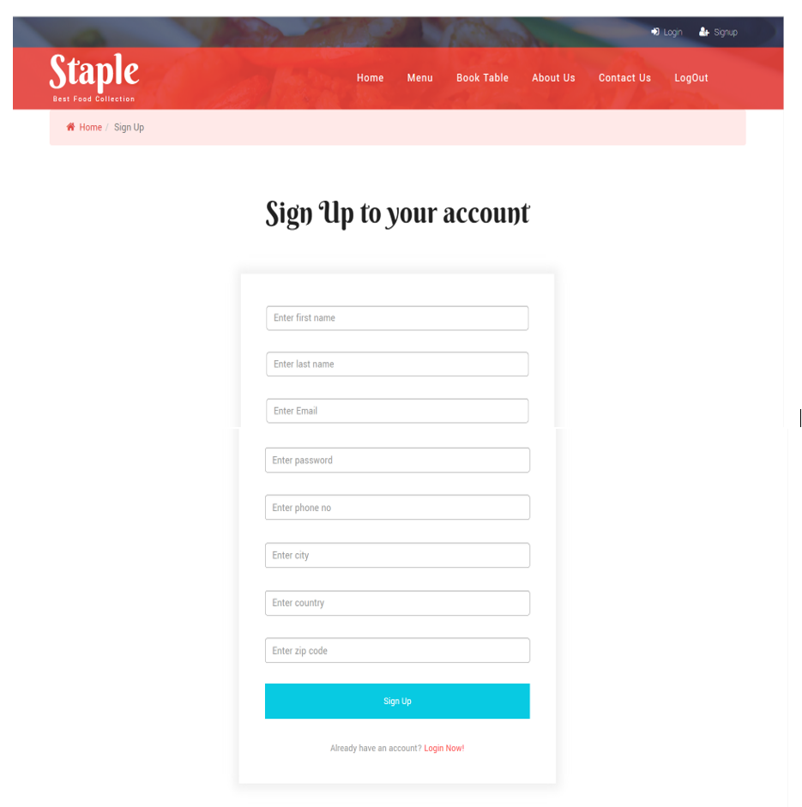

**Figure 3: Sign Up Page [Empty]**

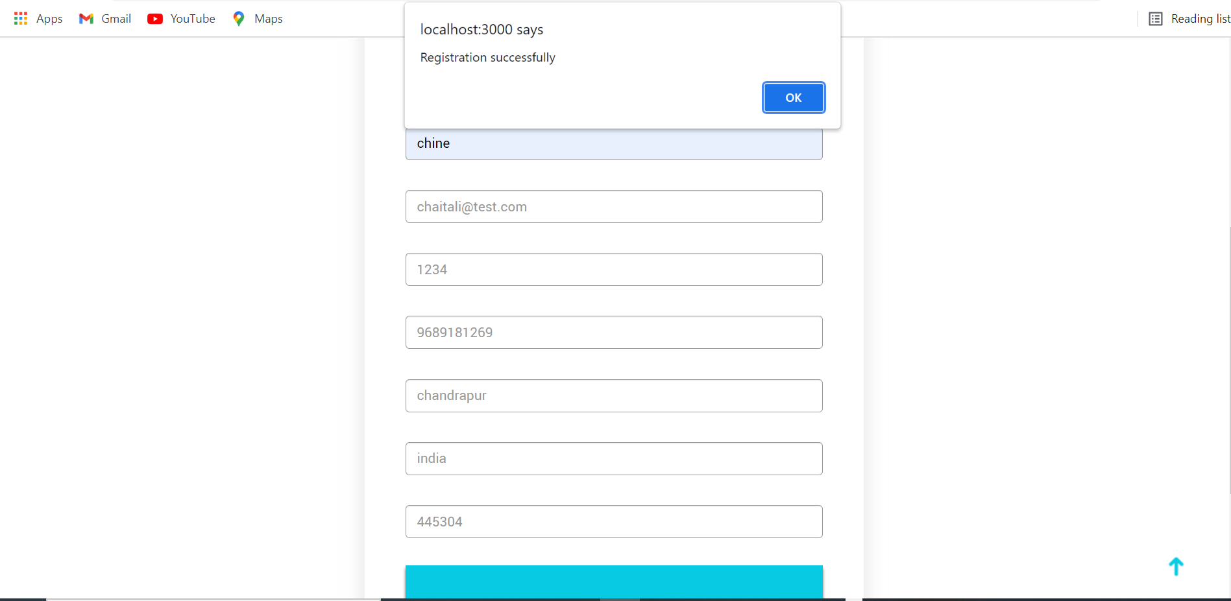

**Figure 4: Sign Up Page [filled]**

**User Login Pages:**

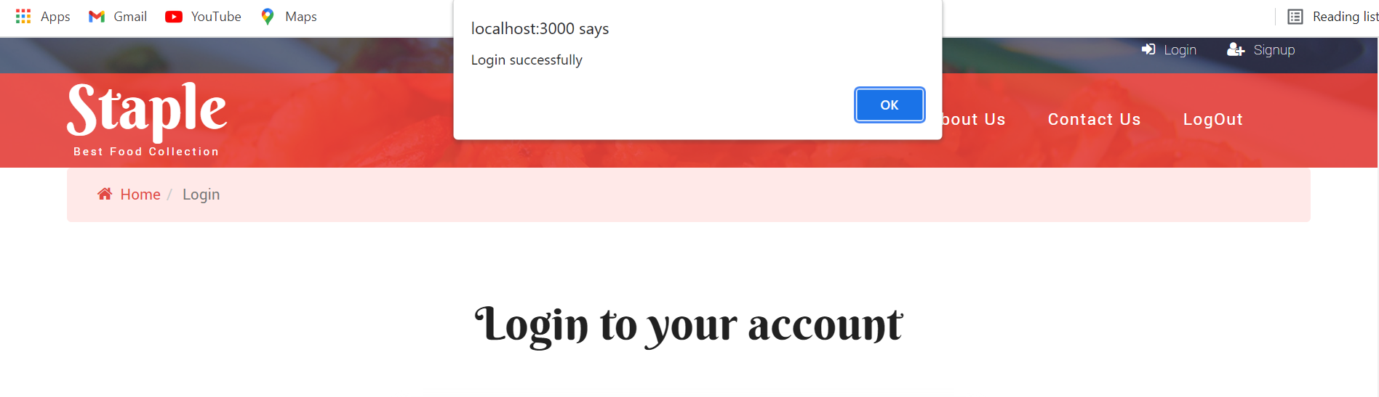

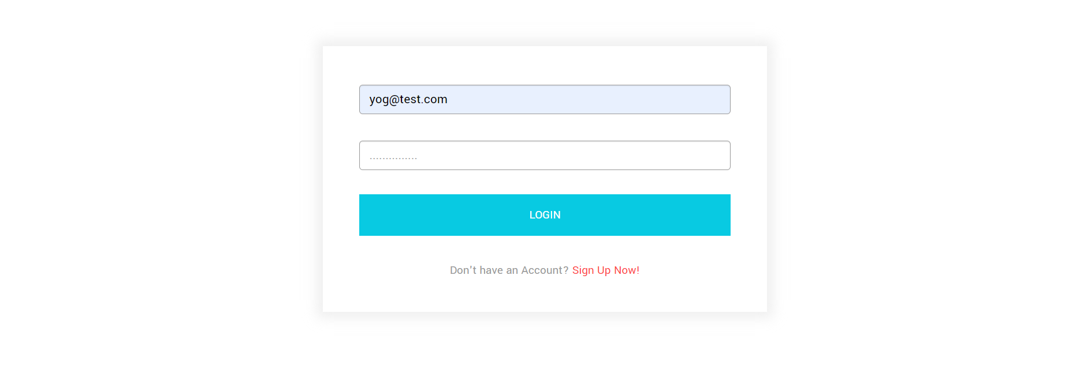

**Figure 5: Login Page [User]**

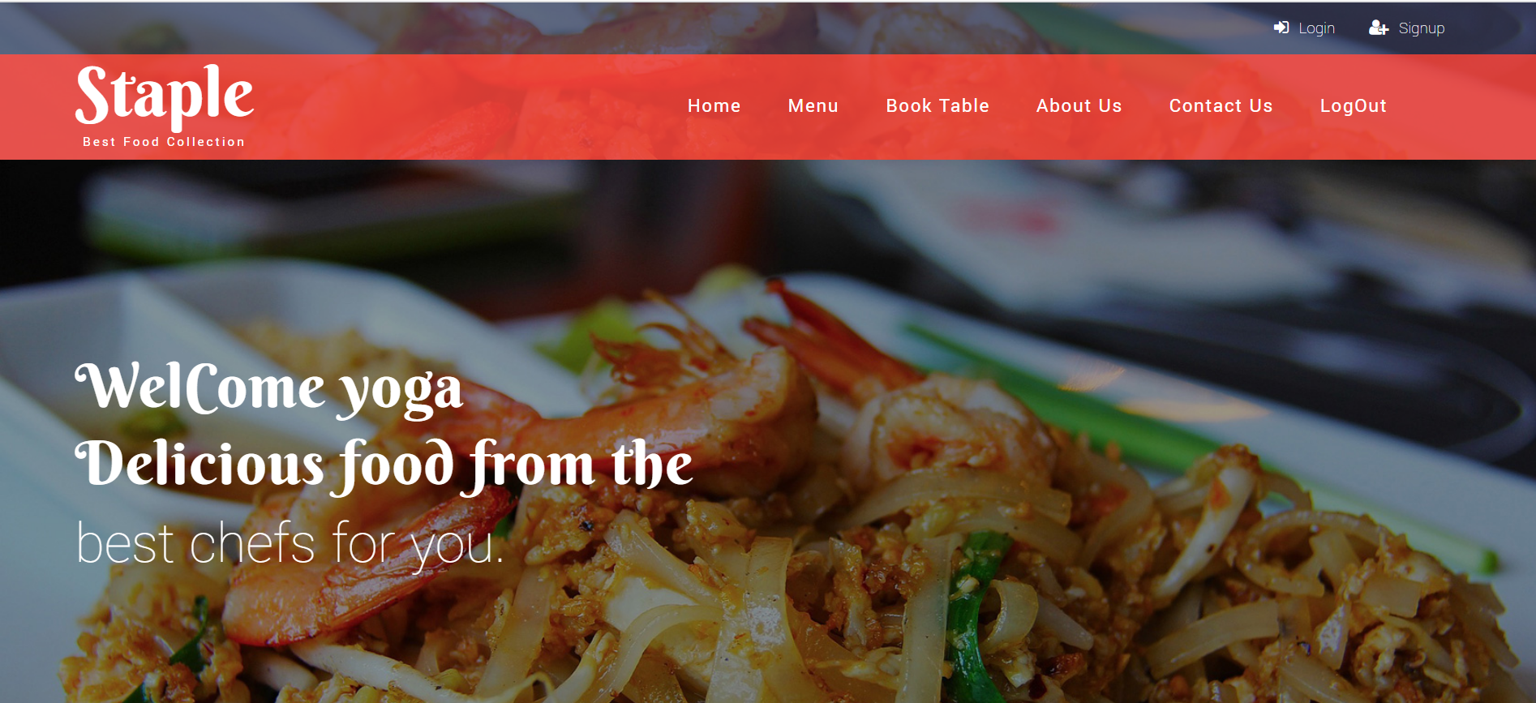

**Figure 6: Home Page [After Login]**

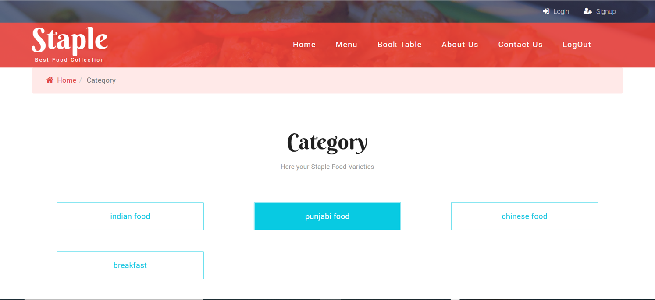

**Figure 7: Category Page**

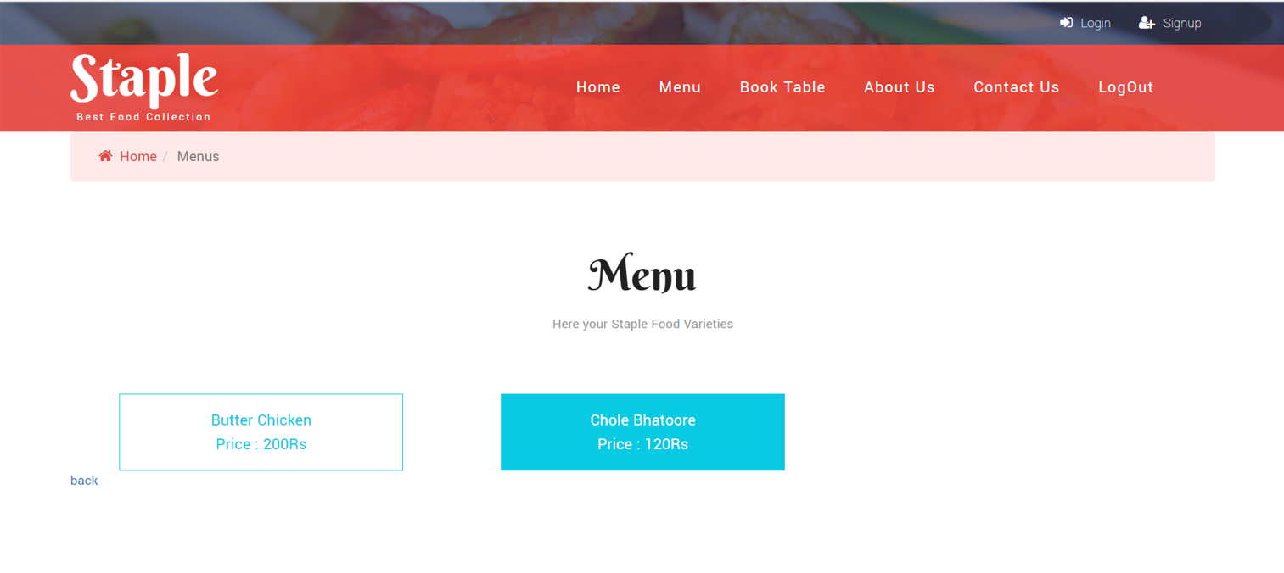

**Figure 8: Menu Page**

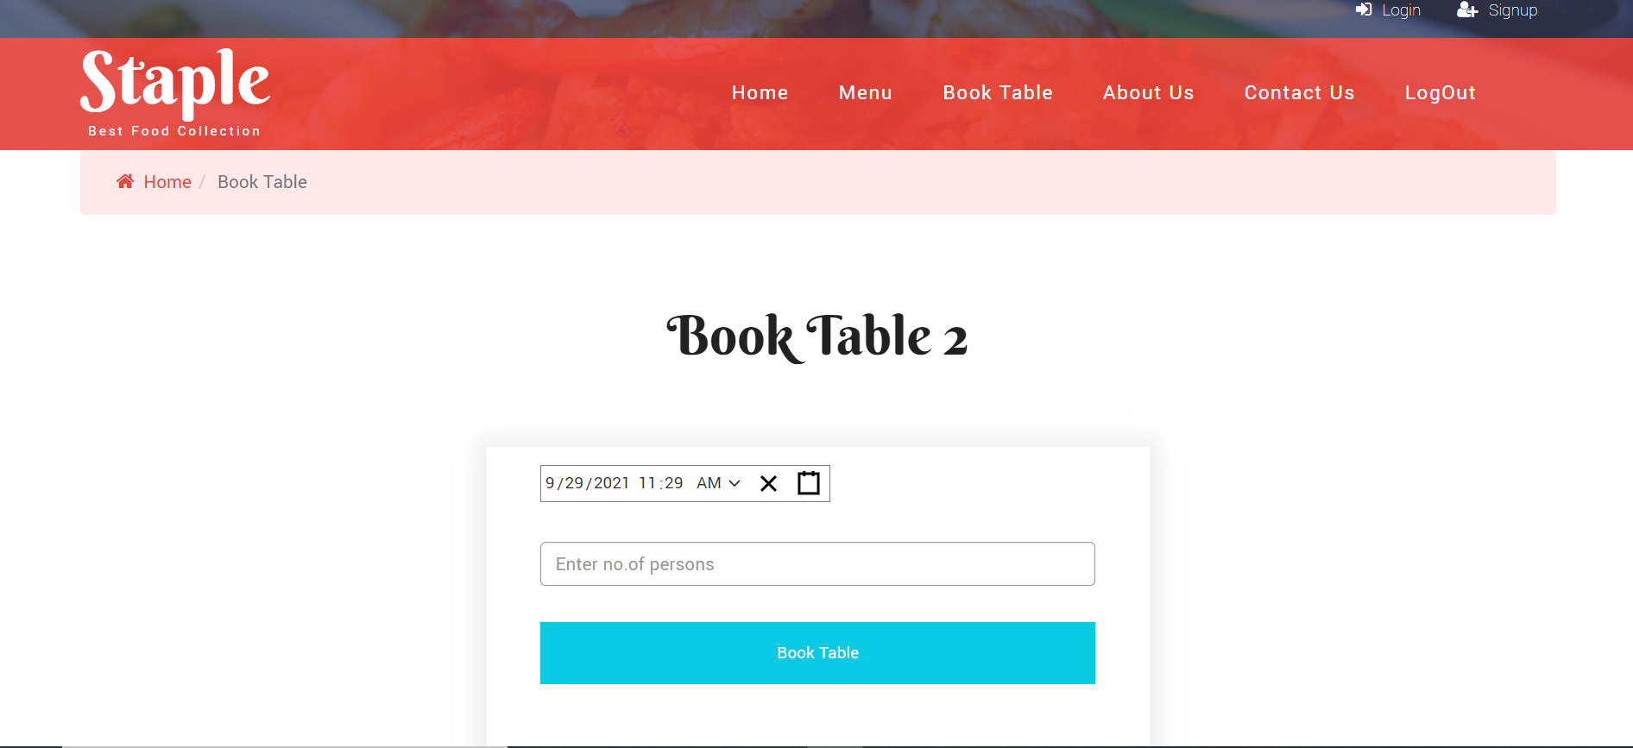

**Figure 9: Book Table [Empty]**

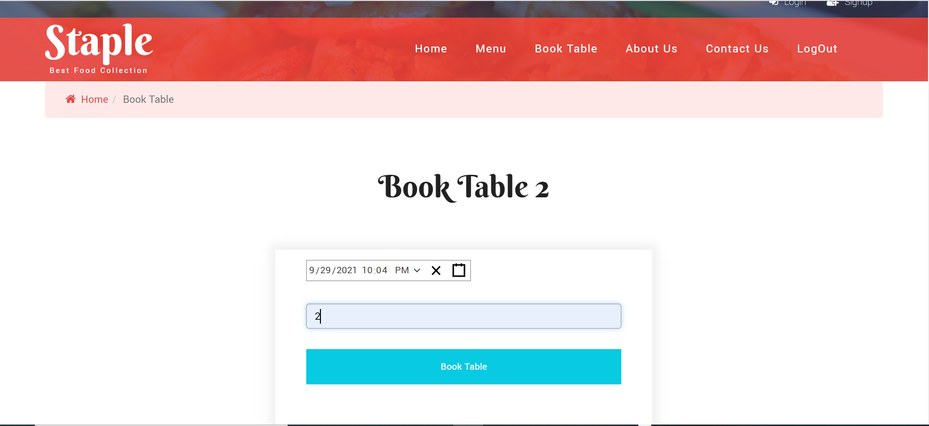

**Figure 10: Book Table Page [Filled]**

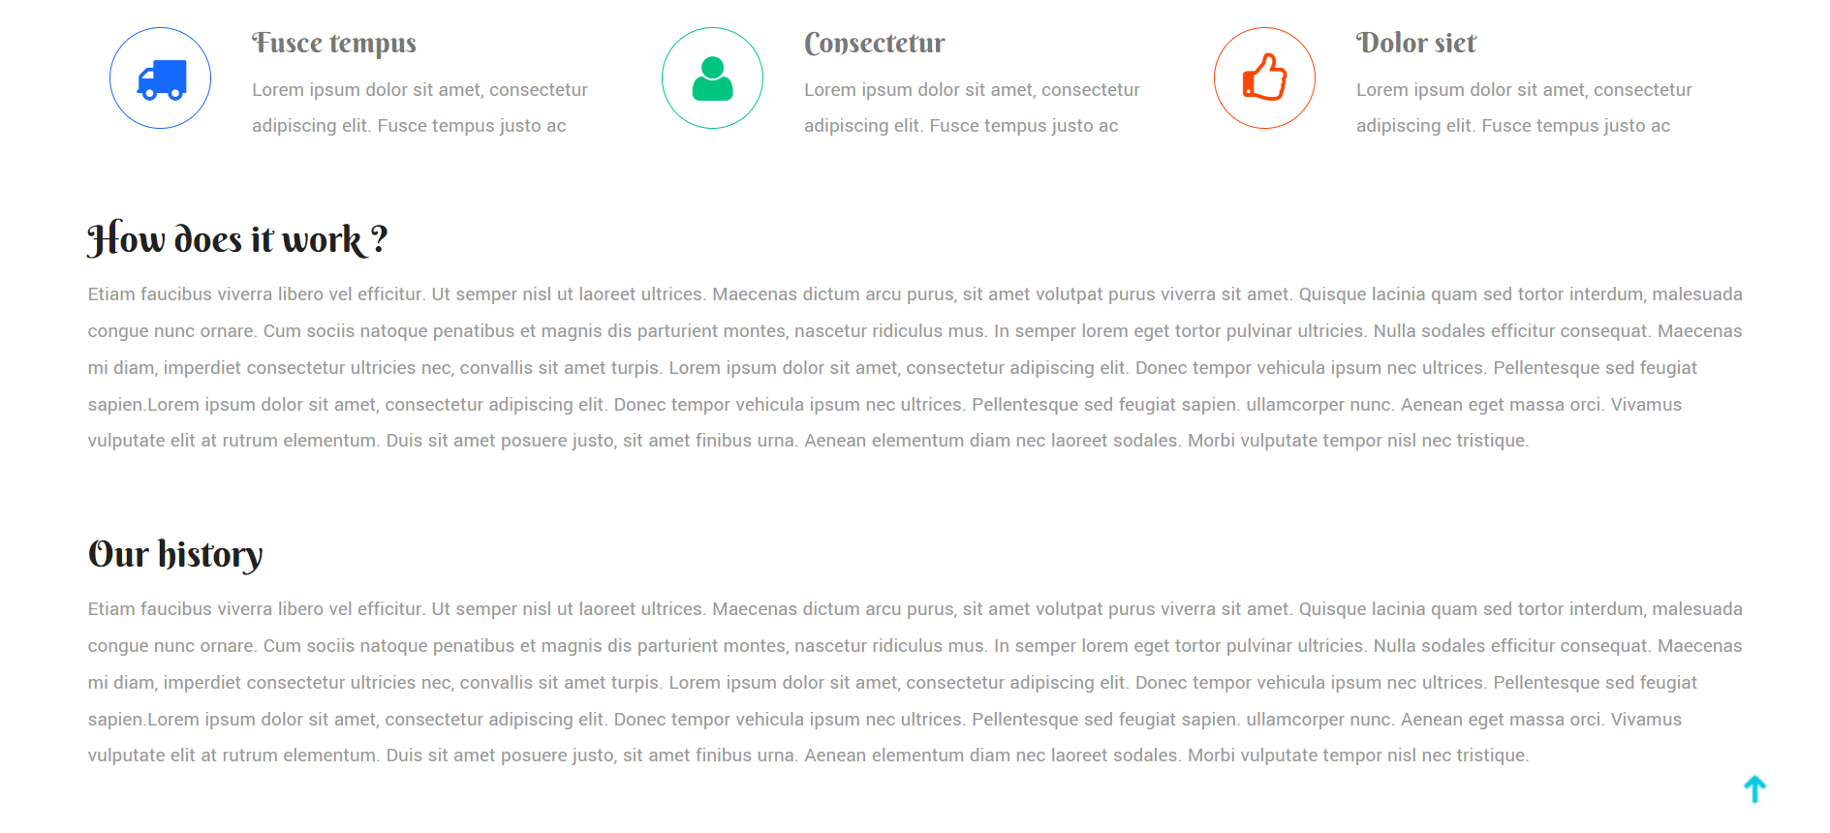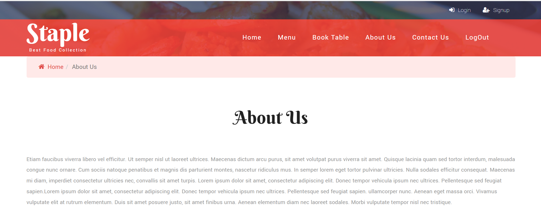

**Figure 11: About Us Page**

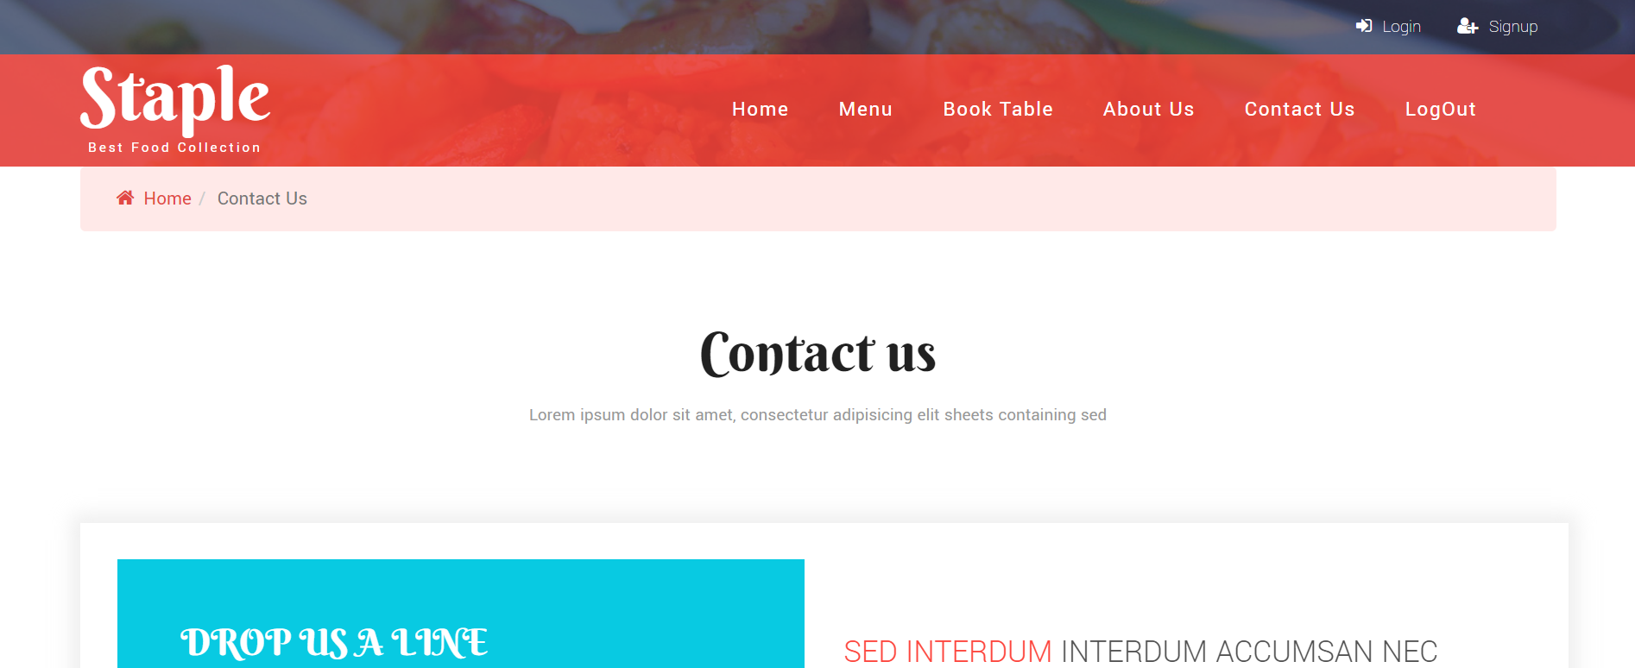 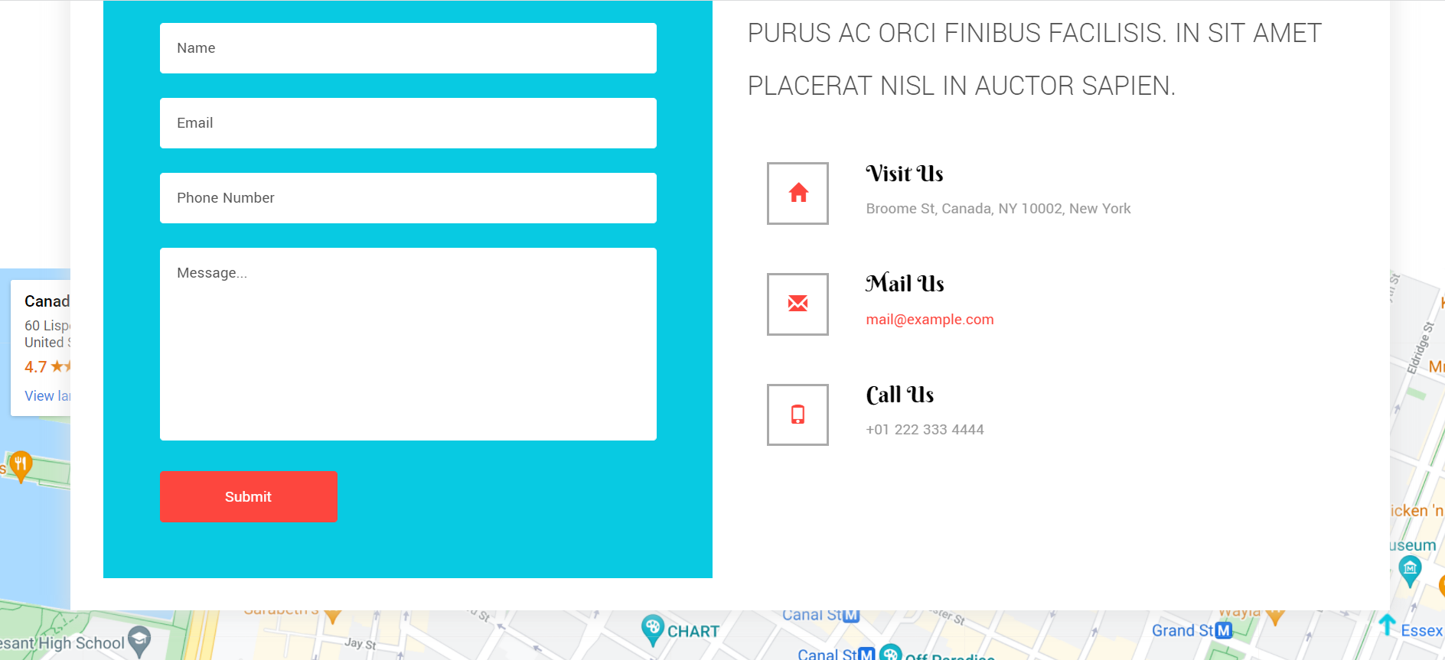

**Figure 12: Contact Us Page**

**Admin Login Pages :**

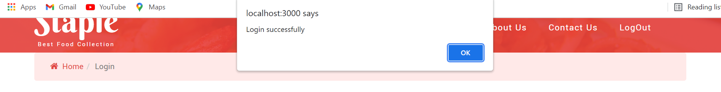

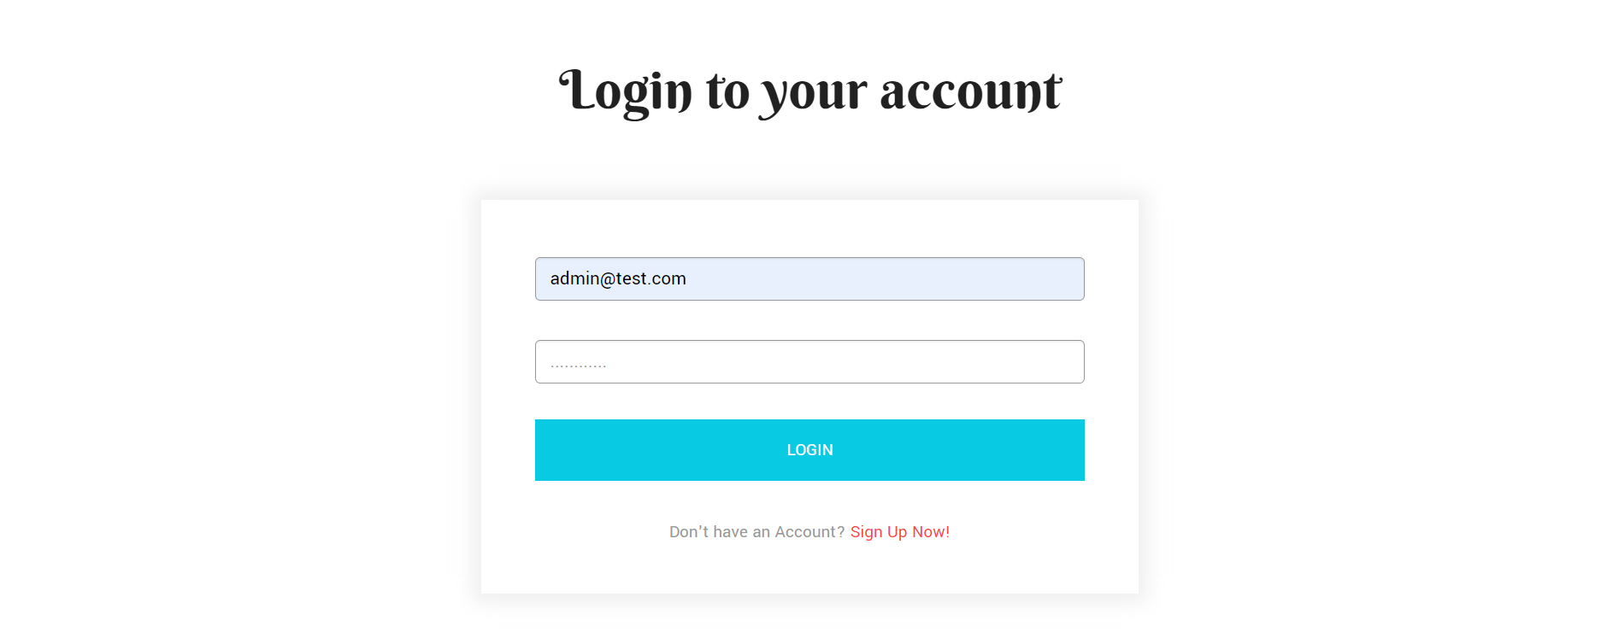

**Figure 13: Login Page [Admin]**

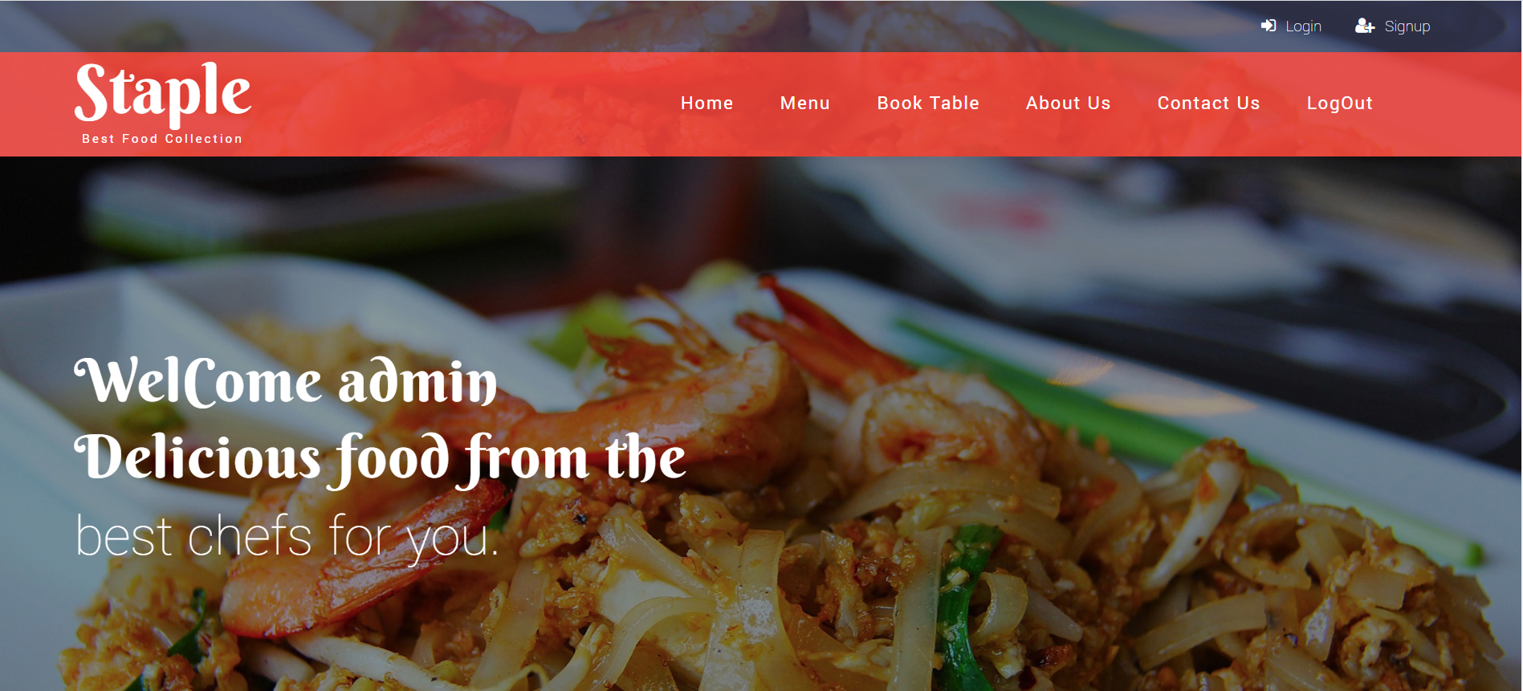

**Figure 14: Home Page [Admin]**

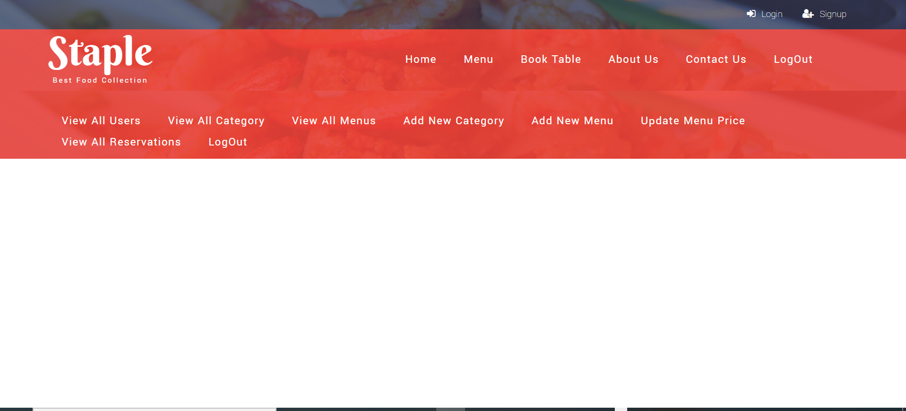

**Figure 15: Admin Page**

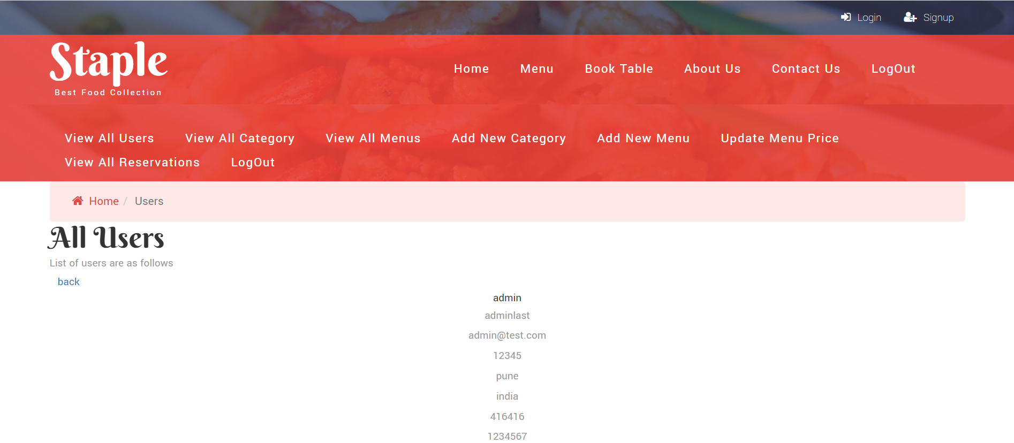



**Figure 16: View All Users Page**

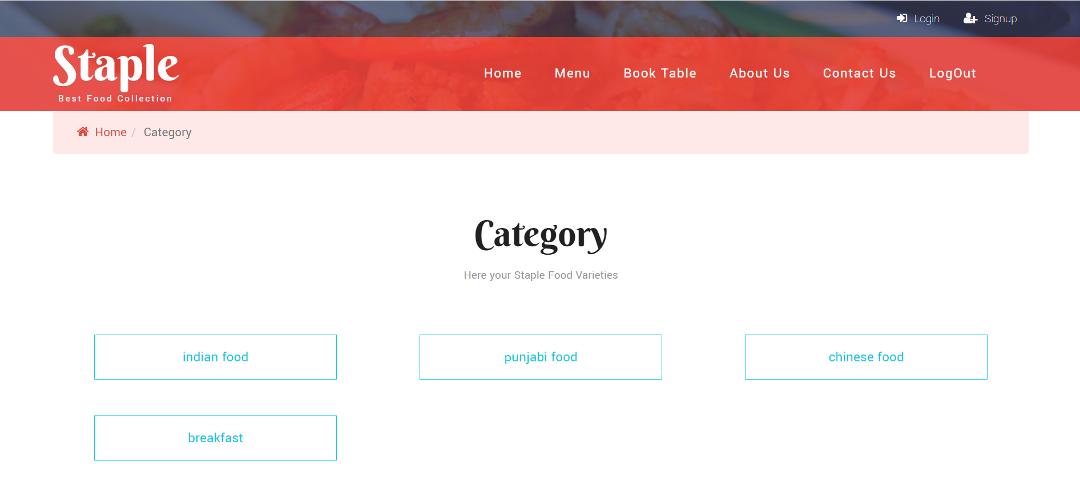

**Figure 17: View All Category Page**

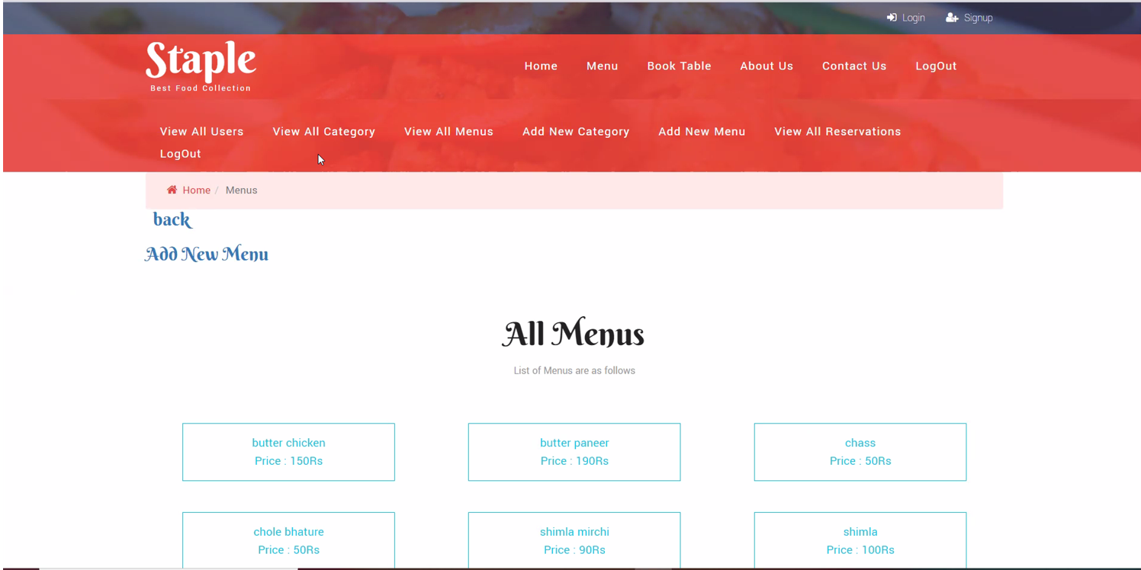

**Figure 18: View All Menu Page**

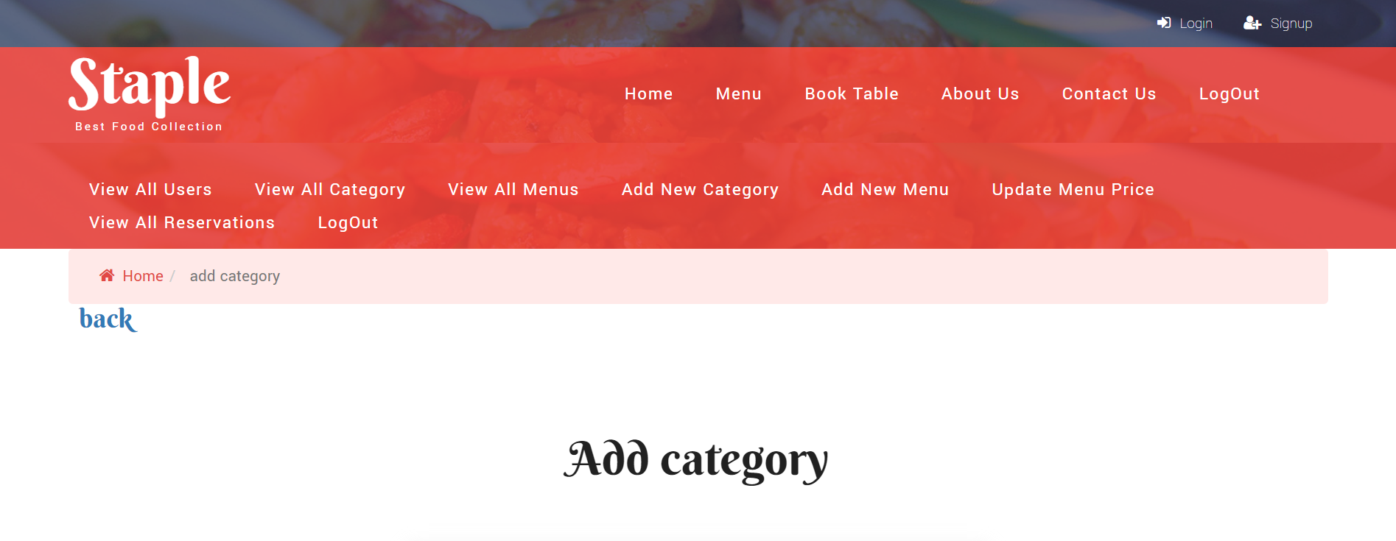



**Figure 6.7 Add New Category Page [Empty]**

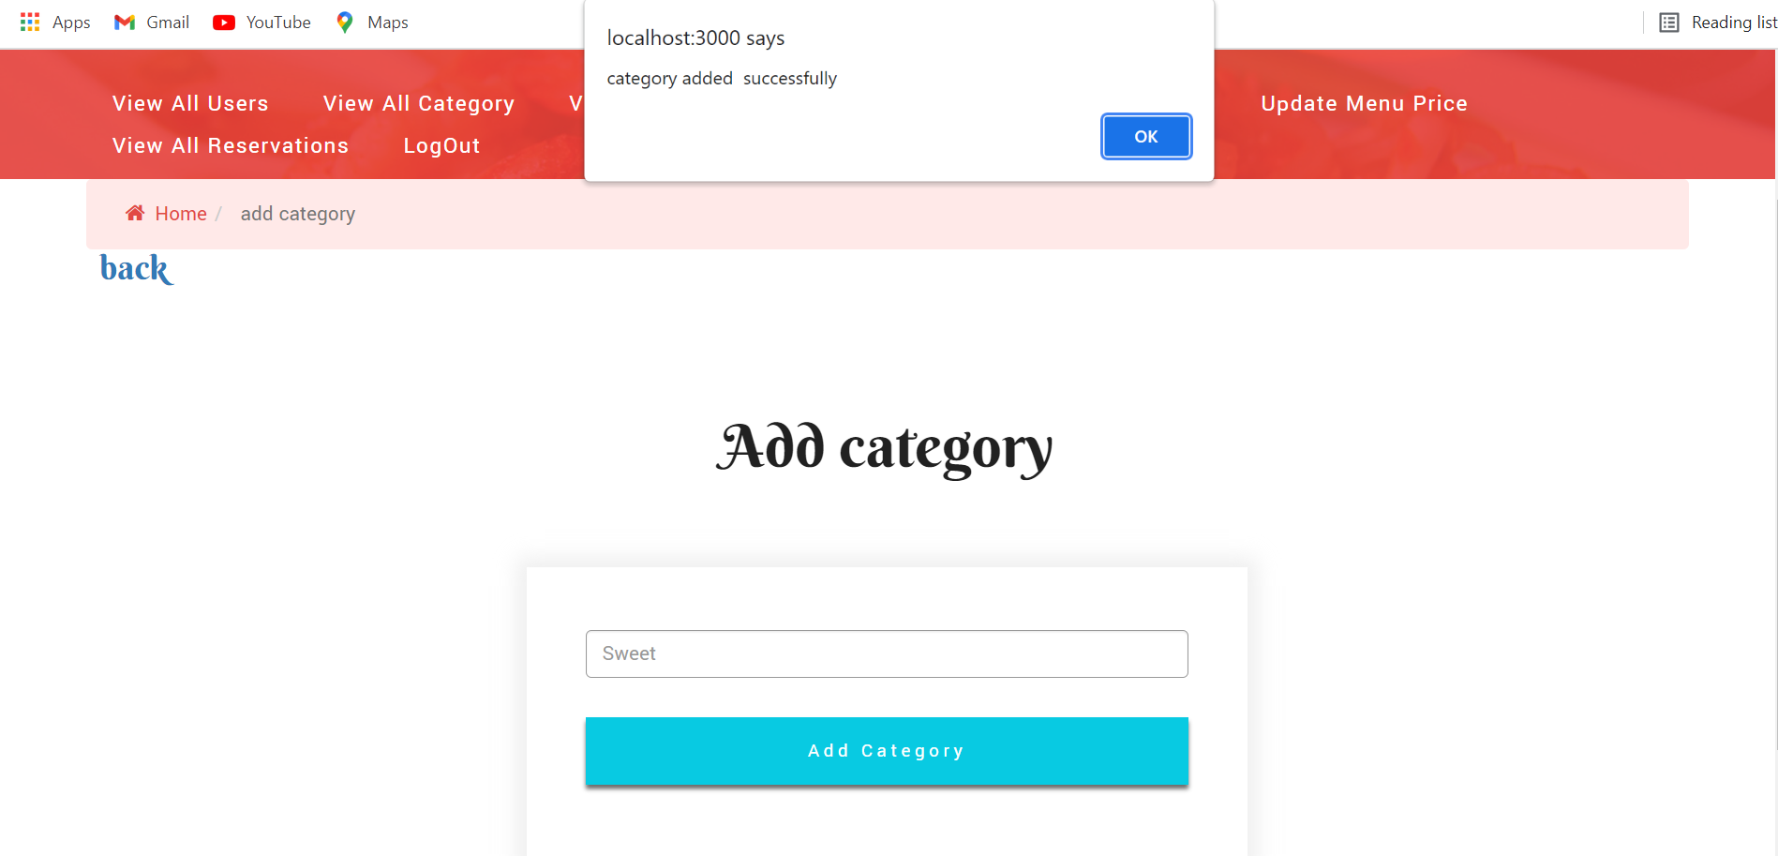

**Figure 19: Add New Category [Filled]**

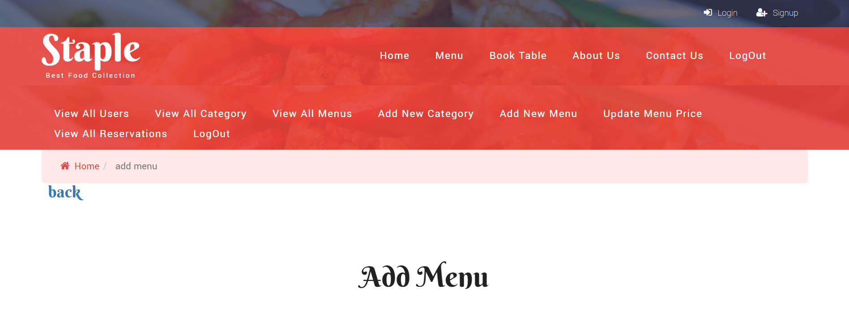

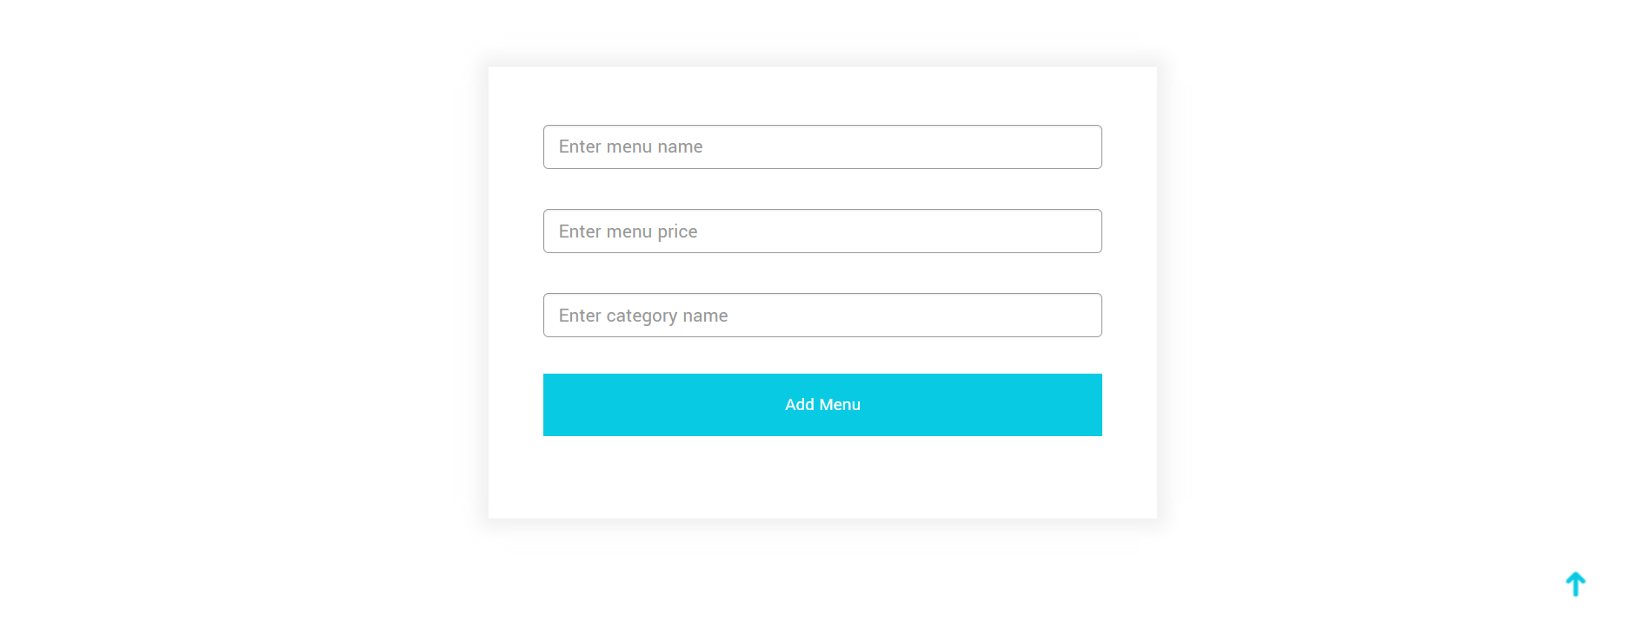

**Figure 20: Add New Menu Page [Empty]**

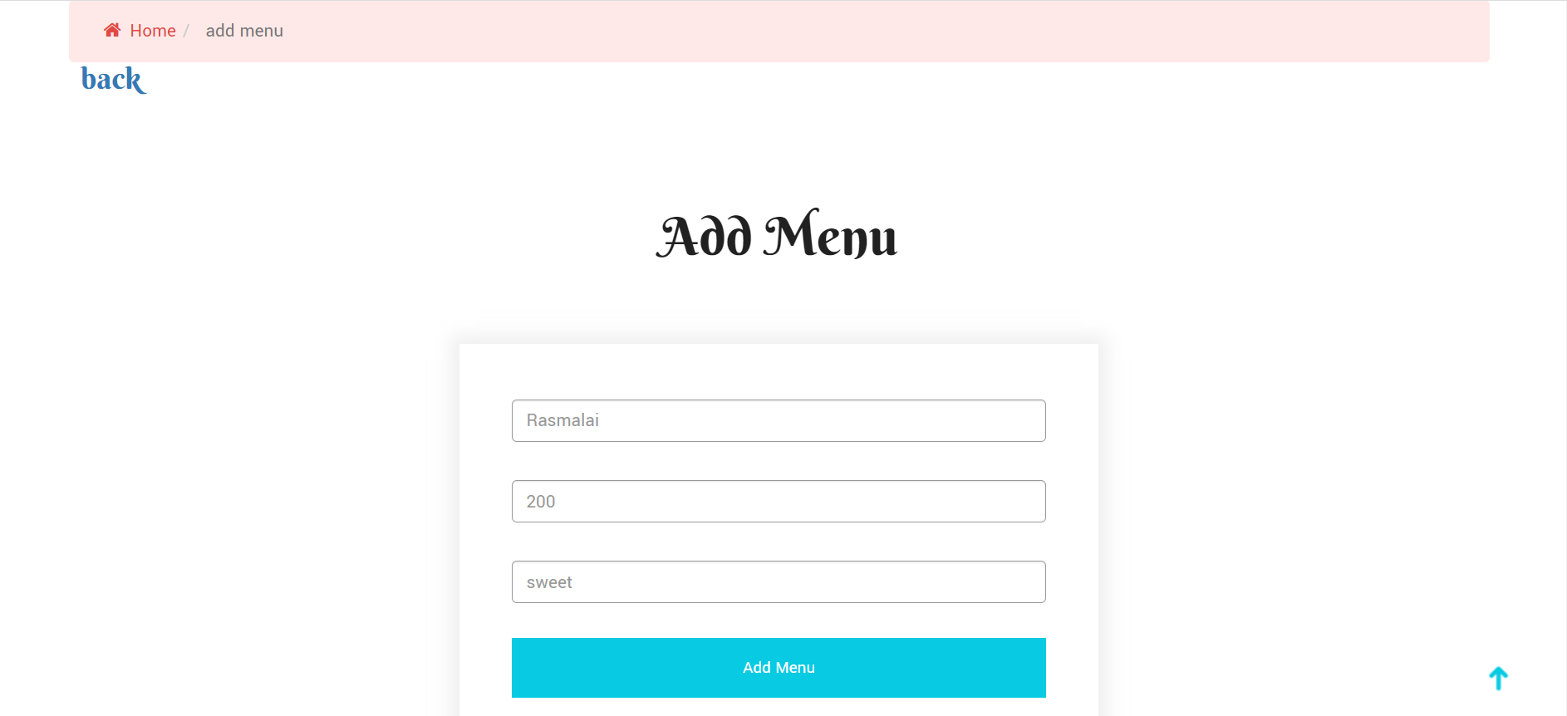

**Figure 21: Add New Menu Page [Filled]**

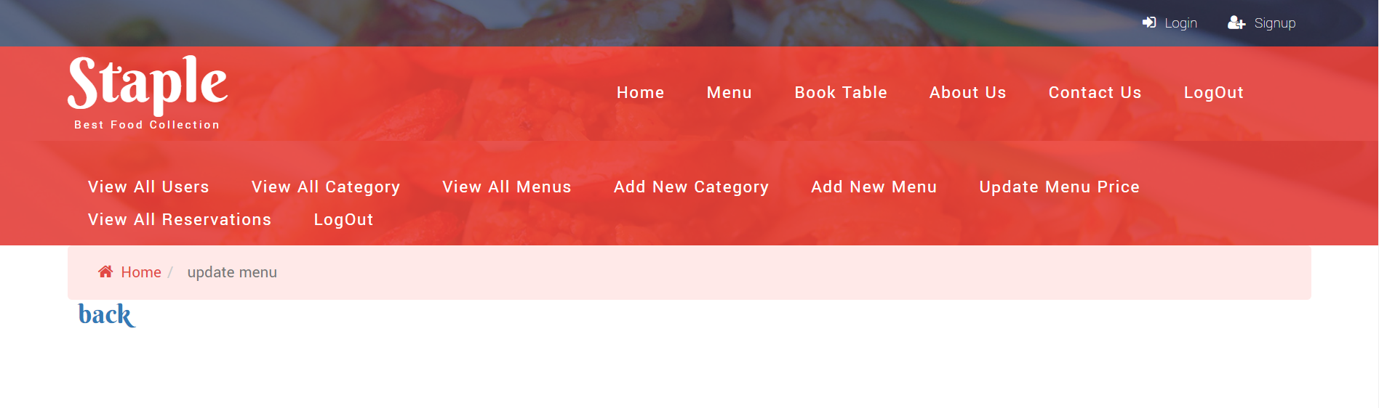

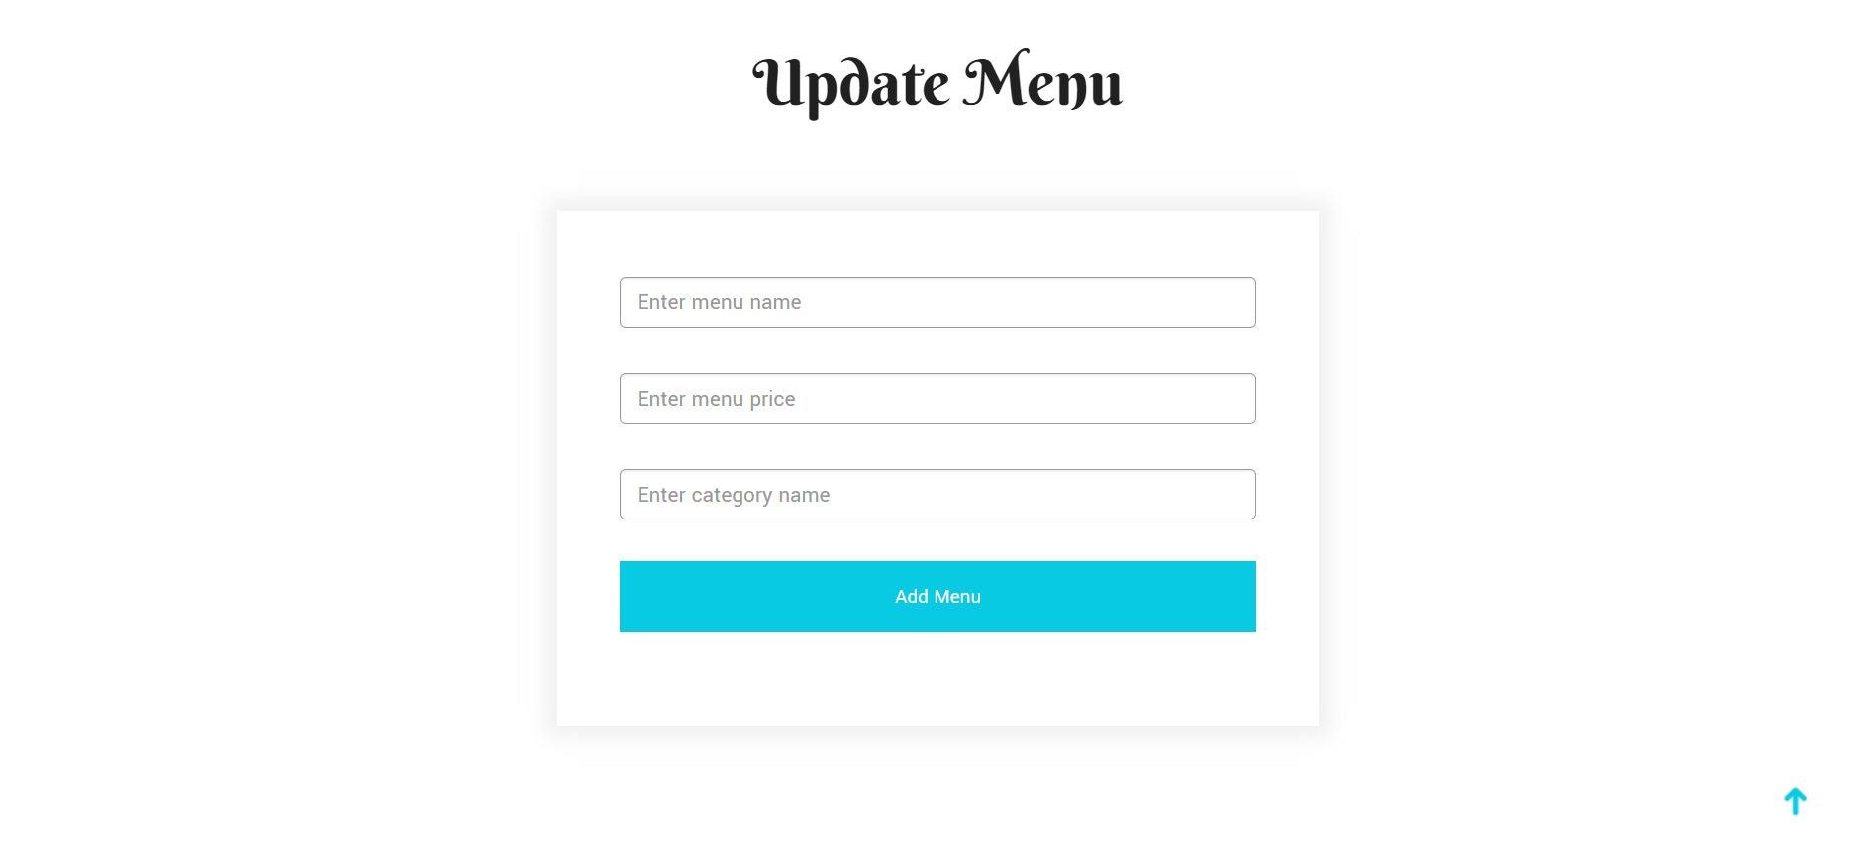

**Figure 22: Add New Menu Price Page [Empty]**

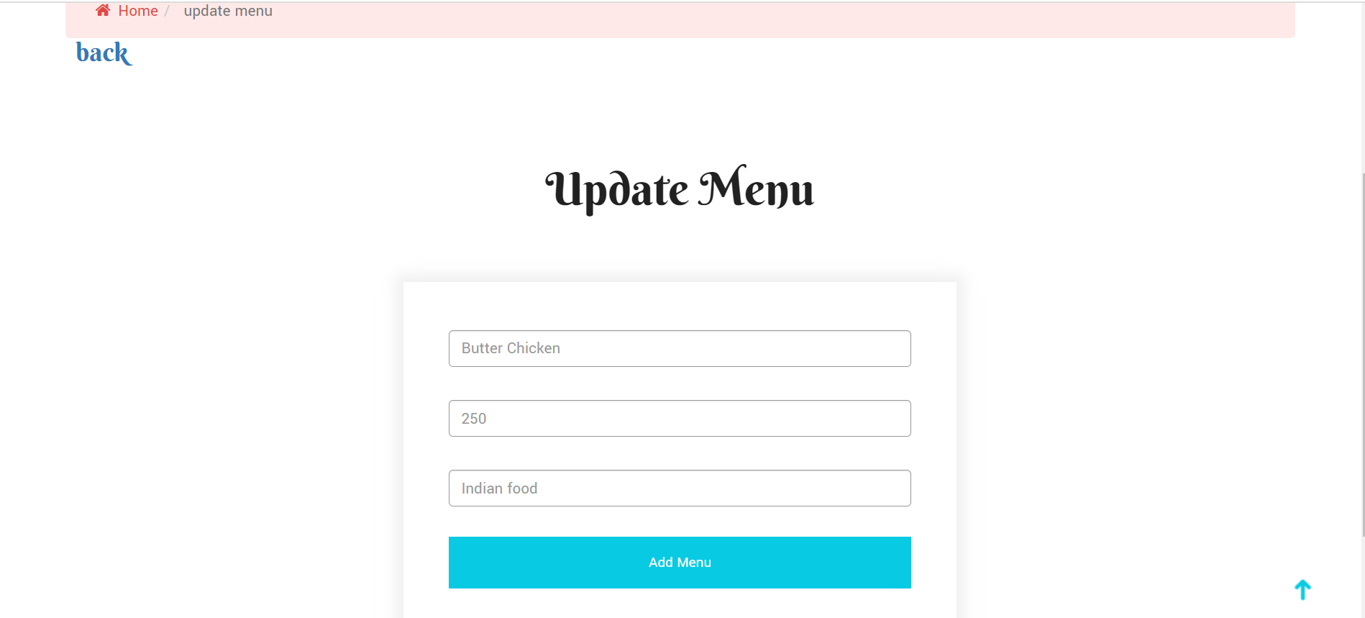

**Figure 23: Update Menu Price Page [Filled]**

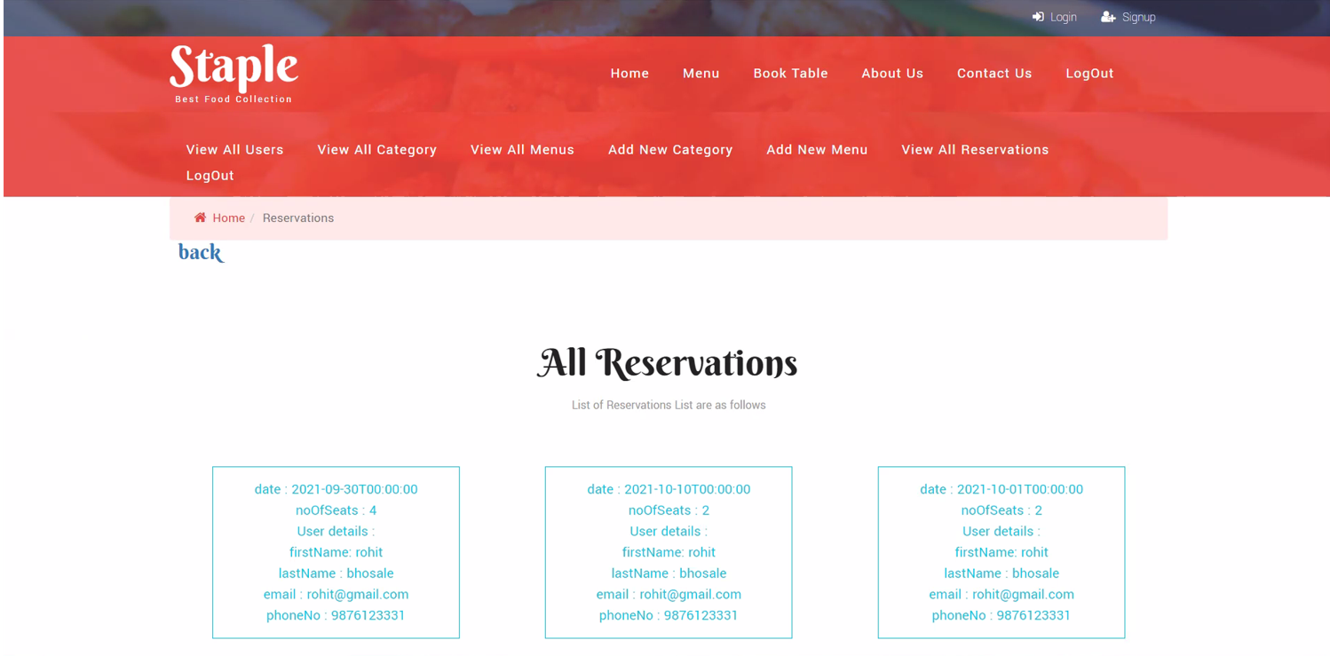

**Figure 24: View All Reservations Page**



**Figure 25: Log-Out Page**

# 7.Conclusion

The project has concluded that if a customer is willing to visit the restaurants

and he finds no table is available for the dinner/lunch then he/she has to wait long

for the table availability. With the help of this web application user can choice the

table‟s location according to their need and willing e .g. Table can be reserved as

according to number of visitors. Moreover, you can easily view ordered food. Kee

-ping in view the demand of proposed project that gives a series of services and

provides the customer to reserve their available tabble without waiting through web

application. In this particular project we have resolved issues being faced by custo

-mers and restaurants staff by developing web application named as RTRSM. This

web application will get its importance as now days more and more people are

getting into fast life.

## 7.1 Future Scope

This project can be enhanced further by adding food ordering and, online payment facility for the members to reduce the extra work of the admin. The software is flexible enough to be modified and implemented as per future requirements. We have tried our best to present this free and user–friendly website to system users. Message and Email alerts for various happenings in the restaurent can be added to the system so that users do not miss the updates of the New Table Reservation deals.

# 8.References

1. N. Rianthong, A. Dumrongsiri and Y. Kohda, "Maximizing service value: A case study of online hotel reservation", 2014 IEEE International Conference on Industrial Engineering and Engineering Management, pp. 803-807, 2014.
2. Chavan, V., Jadhav, P., Korade, S., &Teli, P. (2015). Implementing Customizable Online Food Ordering System Using Web-Based Application.
3. S. Patil, S. Gudasalamani, and N. C. Iyer, "A survey on Iris recognition system," 2016 International Conference on Electrical, Electronics, and Optimization Techniques (ICEEOT), Chennai, 2016, pp. 2207-2211, DOI: 11.1119/ICEEOT.2016.7755084.
4. T. Tan, C. Chang and Y. Chen, "Developing an Intelligent e-Restaurant With a Menu Recommender for Customer-Centric Service," in IEEE Transactions on Systems, Man, and Cybernetics, Part C (Applications and Reviews), vol. 42, no. 5, pp. 775-787, Sept. 2012, DOI: 11.1119/TSMCC.2011.2168560.
5. Ranjan, Vivek &Masiwal, Nikesh & Verma, Nikita &Bharadi, Vinayak. (2013). e-Restaurant: Online Restaurant Management System for Android. International Journal of Advanced Computer Science and Applications. 3. 11.14569/SpecialIssue.2013.030118.
6. <https://stackoverflow.com/>